To do

- For using ML model for search engine maybe I could create a separate app in python using fastApi. Then my javascript app will be comunicating with this python app using its rest api in order to use model for search engine.
- Change the script for preparing data about tables such that it downloads data from database about tables and columns but it is not removing existing tables descriptions
- Improve performance
- Add section about references (which column refers to which columns in other tables). Use references from sql:
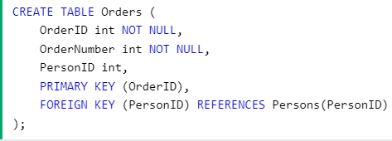
- Build a chatbot

